Columbus City Schools-OSU
Physical Education
for Progress Project

C-PEP

“Impact of PEP Grants on Urban Physical Education”

AAHPERD
General Session

Table of Contents

Subject Page
Agenda 3

Questions 4

Physical Activity Article 5

Overview: Sport Education, Tactical Approach, &
Teaching Responsibility Through Physical Activity 6-7

Teaching self and social responsibility to elementary students 8-16

Using and managing pedometers with elementary students 17-34

Orienteering via Sport Ed. at the Elementary School 35-48

Using Sport Education at the High School-softball 49-64

IMPACT OF PEP GRANTS ON URBAN PHYSICAL EDUCATION

Tentative Session Agenda

8.00am: Introductions and Overview of Three Urban PEP Grants
Diane Barnes, Columbus PS, Jayne Greenberg, Miami Dade PS
Judy Oslin, Cleveland PS/Kent State Collaborative

8.30am: Overview of Curriculum Models Used in PEP Grants
Sport Education – Tristan Wallhead, Ohio State
Tactical Approach to Teaching Games – Dena Deglau, Ohio State
Social Responsibility Model – John Taylor, West Mound Elementary, Columbus Public

9.00am: Columbus PEP Teachers: Teaching Demonstrations (activity session)
John Taylor (Teaching self and social responsibility to elementary students)
Don Cain (Using and managing pedometers with elementary students)
Mary Kennett (Orienteering via Sport Ed. at the Elementary School)
Donna Rioux (Using Sport Education at the High School-softball)

10.00am: Question/Answer Session with teachers on lessons/materials presented

10.10am: Break

10.20am: Cleveland PS PEP: Teaching Videos Samples and Testimonials with Question/Answer Session
Judy Oslin

10.55am Miami Dade’s PEP Program: Jayne Greenberg

11.15am OPEN FORUM Before, during and After PEP

This will be an interaction session with all presenters and the audience. Panels will answer questions on their PEP experience and the impact of these changes on their teaching and their students. Potential questions for this session are attached.

Presenters and Contact Information

Columbus Public Schools - The Ohio State University PEP Collaborative
- Diane Barnes, Co-PI and CPS PE Coordinator (dbarnes@columbus.k12.oh.us)
- Mary O’Sullivan, Co-PI, Ohio State (osullivan.1@osu.edu)
- Don Cain, Projector Manager, Eakin, Reeb, East Columbus Elementary Schools (Doncain1@aol.com)
- Dena Deglau, OSU Professional Development Support Staff (deglau.1@osu.edu)
- Mary Kennett, Teacher Como Elementary School (marykennett@sbcglobal.net)
- Donna Rioux, Teacher, Brookhaven High School (pegym1@msn.com)
- John Taylor, Teacher, West Mound Elementary School (TaylorJohn@hotmail.com)
- Tristan Wallhead, OSU Professional Development Support Staff (wallhead.2@osu.edu)

Cleveland Public Schools /Kent State University Collaborative
- Judy Oslin, Kent State University, (joslin@kent.edu)

Miami Dade County Schools
- Jayne Greenberg
IMPACT OF PEP GRANTS ON URBAN PHYSICAL EDUCATION

Questions Addressed in the Introduction

- What was the state of the district’s PE Program before PEP began?
- What where the reasons to begin the program and what were PEP program’s key goals?
- What was the content (structure/delivery)of the PEP program?

Potential Questions for Open Forum Session

There are some potential questions for the open forum. Feel free to raise these and other questions of direct interest to you of the panel members and other members of the audience. If there are other PEP teachers/administrators in the audience, we hope they will also share their ideas on this process in their schools.

- What has been the impact on districts’ PE programs and teachers following PEP?
- What advice do you have for somebody who wants to write a PEP grant?
- How do you seek/request support from your local university faculty?
- How do you approach your district office to support your PEP initiative?
- How has the university benefited from their involvement with PEP?
- How can you be sure you are aligning your grant proposal with Federal PEP grant guidelines?
- How has your involvement with PEP changed your teaching philosophy or teaching practices?
- How have your students reacted to the ideas you have brought to your program from your PEP experiences?
- In what ways have the students benefited from your involvement with PEP
- How you have as a professional benefited (changed) by involvement with PEP?
- How was technology implemented into the grant and integrated into your teaching?
- How has the status of or respect for physical education in your school/school district changed as a result of the PEP grant?
- How can the momentum of the grant be sustained when the grant funding is gone?

Page 1
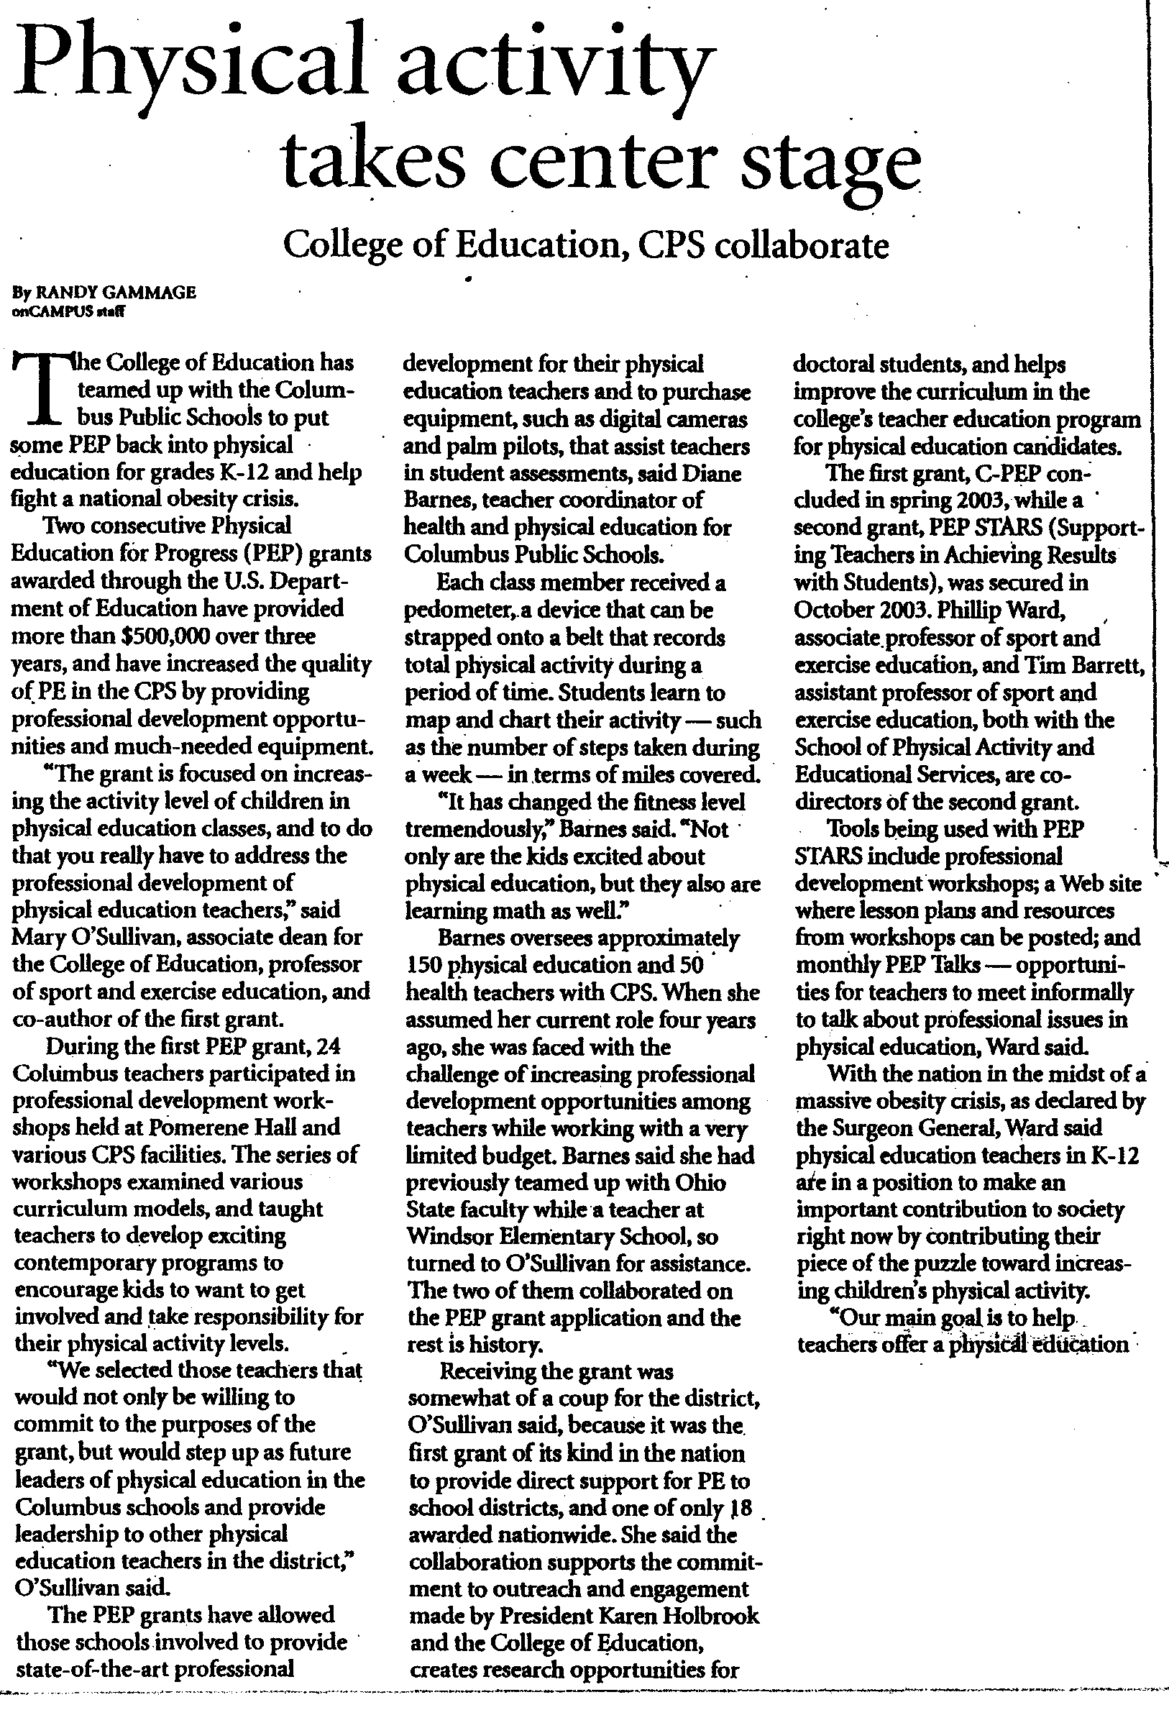
page 2
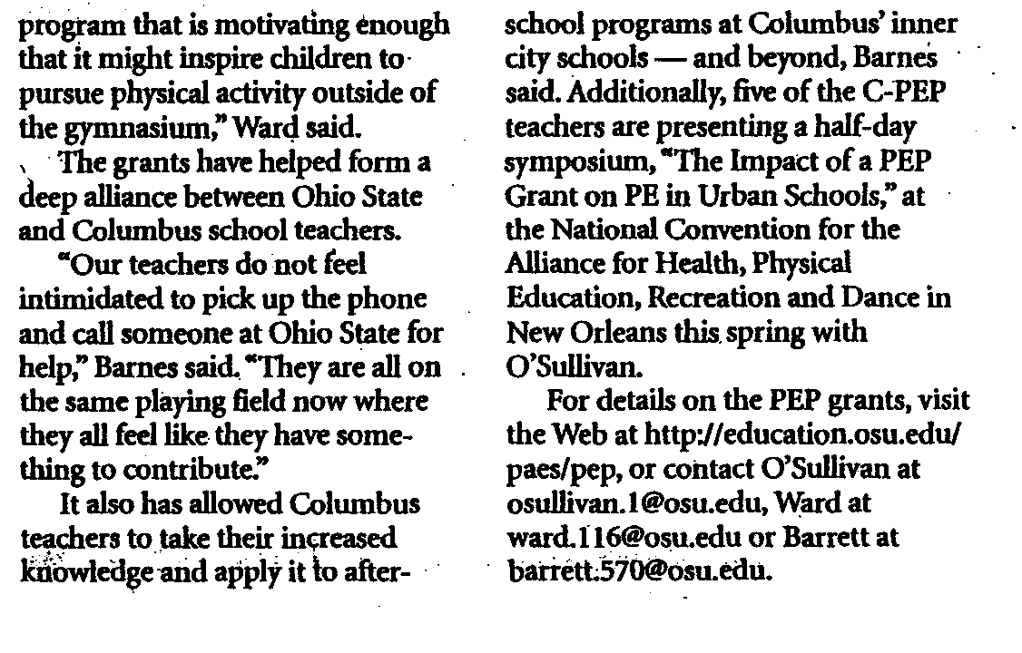
Sport Education
(Siedentop, 1994)

The goal of Sport Education is to produce competent, literate, and enthusiastic sportspersons (Siedentop, 1994). A competent sportsperson is one who can participate successfully in games, because he/she understands and executes skills, tactics, and strategies. A literate sportsperson is one who understands and values the rules and traditions of sport and distinguishes between good and poor sporting practice. An enthusiastic sportsperson promotes, protects, and preserves the sporting culture through the manner in which he/she participates. The goals of Sport Education are achieved by mirroring the positive aspects of “real sport” within physical education units. Siedentop (1994) suggests designing instructional units as lengthy seasons, with students playing on the same team for the duration of a season to develop a sense of affiliation. There is extensive record keeping and the season’s structure is based around formal competition, which leads to a culminating event that is often accompanied by a festive atmosphere. Students are required to perform a number of roles other than player, such as coach, statistician, and referee. Practice, league, and tournament games are part of the season schedule and often modified to maximize student participation. As the season progresses, the teacher gradually gives greater responsibility to students by using less direct teacher-centered styles of teaching and more indirect pupil-centered styles.

Tactical Approach
(Griffin, Mitchell, & Oslin, 1997; Mitchell, Oslin, & Griffin, 2003)

The Tactical Approach (similar to Teaching Games for Understanding; Bunker, Thorpe, & Almond, 1986) has a lot in common with Sport Education, as it also involves students participating in small-sided, conditioned games. Games are the cornerstone of this approach and are used as a means of teaching both the skills and tactics students need to be successful games players. The tactical approach recommends a game-practice-game lesson format, whereby the initial game highlights a problem for students to solve. Following the first game, the teacher questions students to determine how they solved the problem (e.g., how to maintain possession of the ball, what is the highest percentage shot, how to defend an off-the-ball player, etc) and then sets the students up to “practice.” The practice segment isolates the skills and/or tactics needed to solve the problem, which allows the students to see the need for practice. This eliminates the question students frequently ask during skill-drill practice, “Why are we doing this?” After the practice segment, students return to the game to immediately apply what they have learned. This is known in the motor learning literature as whole-part-whole and has been documented as one of the most effective means of motor learning. The tactical approach, as the name suggests, emphasizes the need to teach tactics, and because there are many tactical similarities between games, particularly games in the same category (i.e., invasion, net/wall, target, & striking/fielding games), this understanding is likely to transfer from one game to another. Therefore, if a student learns how to play one game, he/she can transfer that understanding to other games. Physical educators should take advantage of the opportunity to enhance transfer when organizing successive units (or seasons) of instruction.

Teaching Responsibility Through Physical Activity
(Hellison, 2003)

In Teaching Responsibility Through Physical Activity, Second Edition, Don Hellison (2003) guides teachers in using physical activity to foster personal and social responsibility. Hellison provides strategies that have been field-tested in inner city and suburban settings and that help guide students toward greater responsibility. This approach can be used with Sport Education and/or the Tactical Approach or as a stand-alone approach. Taking personal and social responsibility (TPSR) begins with (1) respecting the rights and feelings of others and then progresses to; (2) participation and effort; (3) self-direction; (4) helping others and leadership; and finally (5) trying these ideas “outside the gym.” The recommended lesson plan format includes: counseling time (either during, before or after the lesson); awareness talks to open the lesson; physical activity choices; a brief group meeting near the end of class (which allows students to talk about how the class went and how to make improvements); and reflection time as the close of class (to allow students time to evaluate their level of personal and social responsibility). Hellison offers various strategies for integrating TPSR into the physical activity lesson, transferring TPSR goals outside the gym, empowering students, and developing teacher-student relationships.
AAHPERD NATIONAL CONFERENCE

New Orleans, Louisiana

Teaching self and social responsibility
to elementary students

Presented By:

John A. Taylor
M.S.P.E
Columbus Ohio Public Schools
taylorjohn@hotmail.com
LEVELS OF SOCIAL RESPONSIBILITY
Level Four CARING
Respects others
Participates in activity
Self directed learner
Motivated
Extends sense of responsibility beyond self

Level Three SELF DIRECTED
Shows respect
Participates in activity
Able to work without supervision
Able to identify own needs
Plans and carries out PE expectations

Level Two PARTICIPATION
Shows at least minimum respect to others
Willing to play
Accepts challenges
Practices skill
Participates in PE activities

Level One RESPONSIBILITY
Might not participate in activity or show improvement
Able to control behavior and not interfere with other’s right to learn
Minimal prompting needed

Level Zero IRRESPONSIBILITY
Makes excuses
Blames others for own behavior
Denies personal responsibility for own action, or lack of

INTRODUCTION

“There is no such thing as an individual. We have illusions of Self-sufficiency, but actually other people support us throughout the entire process of our development.
Urie Bronfenbrenner

1. What does this quote mean to you?
2. Does this quote relate to your own philosophy and or P.E. Program?

This quote to me means that ALL individuals are molded and shaped throughout their lives by people and the environment they are in. It is my job as a teacher to impact each student be it small or large in nature so that they can take skills and a decision making process with them when they are contributing members of the community.

1. What are Social responsibility levels and how are they used?

Social responsibility levels are guidelines used for assessing the overall behavior and social skills of each individual child within a class setting and or social setting. Each level has expectations or personality characteristics that students will fall into or exhibit. These levels are used to assess each student’s daily actions/ activities.

LEVELS AND EXPECTATIONS
Level 5 OUTSIDE THE GYM (THE ULTIMATE GOAL)
Students have mastered level four and are able to lead by example and implement
By being an example for others and are able to take theses skills and incorporate them into daily decision-making.

Level 4 CARING

Respects others
Participates
Self directed learners,
Motivated
Extends sense of responsibility beyond self

Level 3 SELF DIRECTED

Shows Respect
Participates
Able to work without supervision
Identify own needs.
Plan and Carries out PE expectations

Level 2 PARTICIPATION
Shows at least minimal respect for others
Willing to play
Accepts challenges
Practices skill
Participates in PE activities

Level One RESPONSIBILITY

Might not participate in activities or show improvement
Able to control behavior and not interfere with others right to learn
Minimal prompting needed

Level O IRRESPONSIBILITY

Make excuses
Blame others for their own behavior
Deny personal responsibility for own actions or lack of

Peer intervention of Level O behavior (irresponsibility)

In dealing with a level zero child and or confrontation in class, I will utilize the Sport court. The sport court is used by incorporating the level four and five children, these children put their skills to the test and mediate the problem, diffuse it, and develop a solution and consequence for the action. The Sport court manager will then report to the teacher and hand in a summary of the outcome.

LESSONS IN ACTION/ COMMUNICATED AWARENESS

Level 1 Can you say that a better way?
Level 2 Try it my way for a week
Level 3 Do you have a goal, you spend the next ten minutes on?
Level 4 Would anyone like to Coach/ demonstrate?
Level 5 Can anyone take something from class and use it outside of class?

COMMUNICATED LEVELS OF AWARENESS

Level 1 You can choose not to help yourself, but don’t take anyone with you.
Level 2 To get better you have to pay the price.
Level 3 You can choose what your friends do, or do what is right.
Level 4 Good idea coach!!!
All Levels It’s your choice, what it going to be?

Juggling Lesson
Grades 4-5

Intro: teacher demonstration of juggling progression of one, two, and three scarves.

10 minutes teaching lesson

Key phrases
- Throw across catch down (One scarf)
- throw across throw across catch down catch down (two scarves)
- First one you throw is the first one you catch
- Focus spot
- If tapped on shoulder may attempt juggling two scarves

Activity
- # Students will attempt to juggle a scarf (teacher will provide feedback)
- # Students will attempt to throw across clap catch down
- #Students will count how many successful attempts completed in a row
- with single throw and throw clap catch down
- # Students will attempt as many catch throws as possible in 30 seconds

5 Minutes

Closing
- Collecting of scarves
- Implementation of Journal entries, Sport Court, and Time out sheets

JOURNAL ENTRIES

DATE _________

Name______________ / Class____________________

I liked/disliked the activity because ________________________________________.

My behavior level was _______ because I _____________________. I would have liked to be at level__________. My skill level completed was _________.
My skill level goal for next class is _________.
I would like to participate in __________________ during P.E. time.

Reflection:

* One thing that I did well today was ________________________.
* One thing you saw someone else do well today is __________________.
* One positive comment you gave today was_________________.
* One thing you like about yourself is__________________.

The word of the week

________________ means to me ____________________________________.

COMMENTS / SUGGESTIONS

Sport Court Resolution form

Date_____ Classroom _____________
(CLEAR, BRIEF, AND CONCISE RESPONSES)
People involved ________________________________________
Problem ________________________________________
Solution ________________________________________
Consequence ________________________________________
Accepted by ________________________________________

IMPLEMENTING SOCIAL RESPONSIBILITY LEVELS INTO DAILY LESSONS

AWARENESS TALK

* Post levels on wall for easy reference
* Relate levels to PE Program and Social interaction
* Give overview of the days activity and expectations

REFLECTION TIME

* Journal activity self assessment and activity summary
* Goal setting setting goal for next class

CLOSING

* Review of class
* Preview of next class
* Summary of overall class social responsibility
* Clean up

Time Out Sheet
COMPLETE SENTENCES AND THOUGHTS FOR RESPONSES
Student _________________________
Grade _________________________
Teacher _________________________
Date _________________________

Why have YOU been removed from class? (Complete sentences and thought only)
____________________________________________________________________________________
____________________________________________________________________________________
____________________________________________________________________________________
____________________________________________________________________________________
____________________________________________________________________________________
What consequences do you feel should result as a result of your behavior or actions?
____________________________________________________________________________________
____________________________________________________________________________________
____________________________________________________________________________________
____________________________________________________________________________________
____________________________________________________________________________________
What could have been the proper actions on your part to avoid the problem?
____________________________________________________________________________________
____________________________________________________________________________________
____________________________________________________________________________________
____________________________________________________________________________________
____________________________________________________________________________________
What would have been the consequences for demonstrating the correct behavior or actions?
____________________________________________________________________________________
____________________________________________________________________________________
____________________________________________________________________________________
____________________________________________________________________________________
____________________________________________________________________________________

__________________
Student Signature
Sample Lesson Plan

Basketball Unit

Awareness Talk:

# Attendance
# review behavior and activity levels
#Safety Guidelines
# Stop when you hear “Buckeyes” Ball between your ankles
# Move to next station when told to do so
# Stay in safe self-space.
# Intro of dribbling activity
#Word of the week for reflection/closure time

Dribbling Activity

MUST BE ABLE TO PERFORM AT THE LEVEL YOU CHOOSE AND BE APPROVED BY TEACHER OR PEER COACH TO ADVANCE TO NEXT LEVEL.

Skill Behavior Activity
Level level level

Beg 2 dribble length of court with r then l hand 2-5 times

Inter 2 dribble length of court with r then l 5+ at jogging pace

ADV 3 dribble length of floor alternating r l hand zig zag jog

Coach 4 devise a two minutes drill that includes dribbling and
Non-dribbling drills. Must be able to explain demonstrate and assist others with practice

Practice 2-4 Dribble obstacle/ dribble tag/
All levels student developed activity from advanced and coach
Levels

CLOSURE/ JOURNALS

# REVIEW AND PREVIEW OF NEXT CLASS/ COLLECT EQUIPMENT
# COMPLETE JOURNAL ENTRIES
# WORD OF THE WEEK

Using and managing pedometers with elementary students

Don Cain
Table of Contents

Subject Page
Unit Plan 19

Block Plan 20

Lesson Plan, (1 of 6) 21-25
Fundamentals in using pedometers

Lesson Plan, (2 of 6) 26-27
Moving across America

Lesson Plan, (3 of 6) 28
Design a Route

Lesson Plan, (4 of 6) 29-31
Soccer Golf

Lesson Plan, (5 of 6) 32-33
Pedometer Scavenger Hunt

Lesson Plan, (6 of 6) 34
Develop a Personal Fitness Routine

References:

Pangrazi, RP., Beighle, A., Sidman, C.L., 2003.
Pedometer power: 67 lessons for k-12.
Champaign, IL: Human Kinetics
UNIT PLAN
Game: Implementing Pedometers Grade Level: 2-8

Pre-requisite skills & knowledge:
(Describe students’ prior experiences/exposure to skills and tactics related to this game.)
- NA

Unit Objective(s):
- Students will be able to measure their physical activity level using a pedometer.

Management Strategies:

Awareness Talks: At the beginning of year each class will receive an Awareness Talk, teaching the following levels:
ZERO: I did not respect the rights and feelings of others
I: I did not participate in all the activities today (but I did respect everyone’s rights)
II: I participated in all the activities today (and respected everyone’s rights)
III: I participated in everything and worked on my own (and respected everyone’s rights)
IV: Besides doing all the other levels, I helped someone (or more than one person)
V: I did level IV, and I intend to try some things from the levels outside of class

Individual Decision Making, “No Plan No Play”: When students have a conflict with others or do not respect the rights of others, I will assign them to sit on the talking step and develop a plan on how they can resolve the conflict.

Group Decision Making, “NBA Time Out”: Students can call a time out if they think there needs to be conflict resolution.

Group Meetings: At the end of class have students gather in a circle and ask them what went right, what went wrong, and ways to improve the class. Teacher writes down improvements for the class and implements at the next class.

During Class, “Counseling Time”: One to One check in, negotiations, personal plans, and trying to talk with each students as an individual.

TAP IN TAP OUT: When students come in they can tap in on what level will be their goal for the day and at the end of class you can ask students or have them tap out of the poster as they leave. Or it can be a thumb up, side ways, or down on the different levels.

Block Plan

Unit: Implementing Pedometers Grade Level: 3-12

Lesson #1 Focus:  Fundamentals in using pedometers  Objective:  To instruct teachers how to deliver a physical education lesson to K-12 students on the fundamentals of using pedometers.  Unit Introductions:  Lesson #2: Moving across America  Lesson #3: Design a Route  Lesson #4 Soccer Golf  Lesson #5 Pedometer Scavenger Hunt  Lesson #6 Develop a Personal Fitness Routine  Warm-ups:  NA  Activity Description:  - INTRODUCTION: (Assessment tool for physical activity)  - Developing lesson plans  - Developing routines for pedometer use  - Check list  Group Reflection:  Ask the students how they did today with their responsibility levels and evaluate how they liked the lesson. | Lesson #2 Focus:  Moving across America  Objective:  - To instruct students the importance of physical activity.  - To allow students to record their total steps taken during physical education.  - To integrate physical activity into academic subjects, including social studies, math, and English.  Warm-ups:  Physical Best, Flip Card File  Activity Description:  While wearing pedometers and recording steps, students will learn how much activity they are accumulating during physical education by implementing Moving Across America. This will allow students to add their total steps and calculate the total number of miles walked.  Group Reflection:  Ask the students how they did today with their responsibility levels and evaluate how they liked the lesson. | Lesson #3 Focus:  Design a Route  Objective:  - To provide students with the opportunity to design walking/jogging routes on school grounds.  - To add variety to a walking/jogging lesson.  - To encourage students to cooperate with classmates.  Warm-ups:  Physical Best, Muscle Magic  Activity Description.  Given maps to students of the school area in groups of three will design a route and record the number of steps their selected routes.  Group Reflection.  Ask the students how they did today with their responsibility levels and evaluate how they liked the lesson.
Lesson #4 focus  Soccer Golf  Objective  - To learn the basic rules of golf.  - To play the game with an emphasis on step counts rather than soccer kicks.  Warm-up:  Physical Best, Push-up-Curl-up Fun  Activity Description:  Soccer balls are kicked rather than golf balls hit. Give the students maps of the course and start the students in groups of three at different holes to decrease the time spent waiting to tee off. Match winners can be based on highest individual step count, lowest, highest group test count and lowest. You also can adapt to Frisbee golf, throwing golf, and rolling golf.  Group Reflection:  Ask the students how they did today with their responsibility levels and evaluate how they liked the lesson. | Lesson #5 focus  Pedometer Scavenger Hunt  Objective:  - To provide students with a fun way to accumulate physical activity.  - To integrate other academic areas into physical education  Warm-up: Physical Best, Balancing the Body  Activity Description:  Set up a course similar to an orienteering course. Place an envelope at each mark with an index card for each group. Adding clues to each card to the puzzle that must be answered. Students will visit all markers to solve the problem.  Group Reflection:  Ask the students how they did today with their responsibility levels and evaluate how they liked the lesson. | Lesson #6 focus  Develop a Personal Fitness Routine  Objective:  - To monitor the level of fitness activity for each student.  - To offer students a chance to control the number of steps they accumulate during fitness activities.  Warm-up: Physical Best, Measuring your heart rate.  Activity Description:  Have students design a fitness routine that alternates aerobic exercises with strength and flexibility exercises. Challenge the students to accumulate a total of 1,200 steps and provide students will the choice of a variety of P.E. equipment.  Group Reflection:  Ask the students how they did today with their responsibility levels and evaluate how they liked the lesson.

PHYSICAL EDUCATION
LESSON PLAN

NAME: _____________________ TITLE: Fundamentals in Using Pedometers

GRADE: 2-12/Teachers DATE: ________________________

SLC: 1 Strand: 3 Physical Fitness

Integration Area (s): Reading and Writing Lesson: 1 of 6

Equipment Needed/materials: Pedometers & Personal Fitness Books.

Lesson/Procedures:

- Objectives: To instruct teachers how to deliver a physical education lesson to K-12 students on the fundamentals of using pedometers.

- Warm-up:
  - Na

- Activity Description: (Assessment tool for physical activity)
  - Electronic pedometers detect movement through a spring-loaded, counter balanced mechanism that records vertical acceleration at the hip. Compared with other currently used assessment tools, self-report questionnaires or diaries, pedometers are now an acceptable method of objectively measuring total daily step counts.
  - Pedometers measure the up-and-down motion of the hip in a vertical plane. Numerous studies have examined the validity of pedometers and have concluded that the device is a suitable tool for assessing the physical activity patterns of students.
  - A primary use of pedometers in physical education is to help students monitor their daily activity and set meaningful goals.
  - When developing a lesson plan for introducing pedometers, do the following:
    - Establish guidelines for use. Some students may shake the pedometer to artificially increase step counts. A consequence is needed to prevent this behavior. “You shake it, we take it” (i.e., loss of the privilege of using the pedometer) is an effective deterrent.
    - Discuss how pedometers work, including why they are suitable for physical education. To hold the interest of the students, keep the introduction short, about 2 to 3 minutes. If necessary, break up a long discussion by allowing the students to try the pedometers and come back later for more instruction.
    - After a brief discussion, distribute the pedometers to the class. Encourage the students, under supervision only, to satisfy their curiosity about the pedometers. Let the students open the devices, shake them, reset them, and listen to them.
    - Teach students how to wear the pedometers. Pedometers are worn of the waistband directly above the knee. You should provide belts to students who wear dresses, overalls, or other types of beltless garments. Nylon belts similar to the type used for flag football works very well and are easy to make.
    - Once the students have the pedometers properly attached to their waists, have them walk inside the teaching area.
    - Finally, have the students engage in a few teacher-directed games while wearing the pedometers. While participating in activities, students periodically read the pedometers to determine their activity levels. Let the students know that their pedometer steps are private and personal, and they have no obligation to share their step counts with their peers.
- Developing Routines for Pedometer Use
  - Assign each student a pedometer that has been labeled with an identifying number. Students use only their assigned pedometers during physical education class. Students in other PE classes are assigned these same pedometers.
  - Keep a master list of which pedometer is assigned to which student.
  - Designate a retrieval area for the pedometers. This can be on a stage around the perimeter of the teaching area, or in a storage device. Use the same area each lesson, and place the pedometers in the same sequence to expedite distribution and return.
  - We suggest that one student is chosen as a team leader for each team and they are responsible for retrieving their team’s pedometer case, belts, and personal fitness books and return back to their teams designated area to distribute the pedometers to their team. When the pedometers are distributed the pedometer box is returned to the retrieval area as soon as possible. During this time ensure that you remind the students to reset their pedometer to zero prior to starting their physical activity.
  - At the conclusion of class instruct the team leaders and/or equipment managers to retrieve their team pedometer case and collect all the pedometers and return the case after their team records all pedometer information in their personal fitness books.
  - Ensure that the “Fundamentals in Using Pedometers” checklist is discussed with all pedometer users.
- Group reflection:
Ask students/teachers if they think the pedometers can be used in their school.
Fundamentals in Using Pedometers
Checklist
Ensure that the following bullets are discussed to all classes when introducing pedometers:
Introducing Pedometers to a Class:
    - Who has used pedometers prior to this session or implemented pedometers?
    - Purpose: to increase physical activity levels.
    - Pedometers are small devices that measure steps or physical activity.
    - Divide participants up into four groups
    - Create team names, select pedometer numbers, 1 team leaders, and 2 equipment managers.
    - Explain retrieval process with personal fitness books, belts, and pedometer cases.
After Pedometers Have Been Given to Students
- Explain in detail the terminology of the pedometer and how you retrieve information.
  - Explain how you open the pedometer while it is on your body using the top clip.
  - Explain the three modes of the pedometer, 1. ex time 2. mile 3. Step
  - Reinforce that the students should never press the Set button in the middle. This will erase all programmed stride length for the pedometer.
  - Explain the holding the yellow reset button for 2-3 seconds will reset their pedometer to Zero.
- Under your supervision, allow students to shake the pedometers to observe the numbers increasing, and then reset the pedometer.
- Set the rule, “You shake it, I take it.” (Explain that shaking destroys the accuracy of pedometers.) Cheating.
- Demonstrate correct placement and allow students to practice putting the pedometers on. Attach the pedometer to your waistband or belt directly above the knee. Make sure it is closed.
- Discuss belts for students without waistbands.
- Have students reset the pedometers and walk in the teaching area, periodically checking the pedometers.
- Allow students to participate in teacher-directed activities while checking the pedometers from time to time.
- Assure students that step counts are private and do not have to be shared with classmates.
- Explain that the retrieval/return system will require several practice opportunities for children to become efficient with the routine.
- Reinforce the importance of honesty, respect, and cooperation when using pedometers. Remind students that using pedometers is a privilege that can be revoked for bad behavior.

Sample Pedometer sign-out sheet

SCHOOL _____________ ROOM # __________________
Name | Pedometer #

SCHOOL _____________ ROOM # __________________

Name | Pedometer #
Sample recording log
DATE | TYPE OF EXERCISE | EXERCISE  TIME | # OF  STEPS | # OF MILES
PHYSICAL EDUCATION
LESSON PLAN

NAME: _____________________ TITLE: Moving across America

GRADE: 3-12 DATE: ________________________

SLC: 1 Strand: 3 Physical Fitness

Integration Area (s): Reading and Writing Lesson: 2 of 6

Equipment Needed/materials: Pedometers & log sheets.

Lesson/Procedures:

- Objective:
  - To instruct students the importance of physical activity.
  - To allow students to record their total steps taken during physical education.
  - To integrate physical activity into academic subjects, including social studies, math, and English.

- Warm-up: Physical Best, Flip Card File

- Activity Description:
  - Explain to the class that they will track their progress across the designed area, and you will track the class’ progress across the United States.
  - Give the students a map of a smaller area (city or county) on which to track their progress. A mileage scale should be shown on the map. Predrawn routes with the corresponding distances labeled on the map may be useful (e.g., routes from cities to landmarks or from city to city).
  - Allow the students to wear pedometers and record their steps and mile counts in P.E. class.
  - Allow the students to track their progress on their maps using predetermined routes or routes of their choice.
  - Calculate and chart the total miles for each class on the large map of the United States.
- Classroom Integration:
  - As classes progress to different regions or states, the PE teacher or classroom teacher asks the students to find some unique geographic characteristics of the state or region. To learn directions, students determine what is north, south, east, or west of their current location.
  - An imaginary trip around the U.S. through the use of P.E. central Log It can be used throughout the entire school year. This also can be done by using the classroom teachers yearly plan for history by establishing routes around these lessons.
  - Teach developmentally appropriate rhythm routines using music from different regions or states.
  - Art class activities can be coordinated with pedometer use. Have students make posters or other projects that advocate physical activity or a healthy lifestyle in the region they are currently visiting and use those posters to decorate the gym or school.
- Group Reflection:
Ask the students how they did today with their responsibility levels and evaluate how they liked the lesson.
PHYSICAL EDUCATION
LESSON PLAN

NAME: _____________________ TITLE: Design a Route

GRADE: 3-12 DATE: ________________________

SLC: 1 Strand: 3 Physical Fitness

Integration Area (s): Reading and Writing Lesson: 3 of 6

Equipment Needed/materials: Pedometers, log sheets, and maps.

Lesson/Procedures:

- Objective:
  - To provide students with the opportunity to design walking/jogging routes on school grounds.
  - To add variety to a walking/jogging lesson.
  - To encourage students to cooperate with classmates.

- Warm-ups:
Physical Best, Muscle Magic

- Activity Description:
  - Draw maps of the school area and mark locations that are off-limits.
  - At the beginning of the lesson, discuss the importance of walking/jogging in promoting health and fitness. Explain the importance of pace and walking with a friend. Discuss safety issues such as avoiding high-traffic streets, not talking to strangers, and walking where other students and parents walk.
  - Organize the students into groups of three or four. Ask each student to wear a pedometer.
  - Give each group a map of the school grounds.
  - Record the number of steps the students needed to walk their selected routes. Calculate the total score by adding the scores of all students in the group. Mark the legend for the map in steps.

- Variations:
  - Allow groups to switch maps and walk other routes.
  - Ask students to guess how many steps the route will require before they start the walk.
  - Let the students use routes from other classes and see if their group has the same number of steps. Discuss why or why not?

- Group Reflection.
Ask the students how they did today with their responsibility levels and evaluate how they liked the lesson.

PHYSICAL EDUCATION
LESSON PLAN

NAME: _____________________ TITLE: Soccer Golf

GRADE: 3-12 DATE: ________________________

SLC: 1 Strand: 3 Physical Fitness

Integration Area (s): Reading and Writing Lesson: 4 of 6

Equipment Needed/materials: Pedometers, log sheets, cones/markers, and soccer balls.

Lesson/Procedures:

- Objective
  - To learn the basic rules of golf.
  - To play the game with an emphasis on step counts rather than soccer kicks.

- Warm-up:
Physical Best, Push-up-Curl-up Fun

- Activity Description:
  - Teach the students the rules of soccer golf. Post a rules sign and course map at teach tee box.
  - Boundary cones with numbers are used for tees, and holes are marked with boxes, hula hoops, trees, tires, trash cans, or any other available equipment on the school grounds. Areas around swings and slides can be designated bunkers or out of bounds.
  - Draw a course map and provide a copy for every three or four students.
  - Start the groups at different holes to decrease the time spent waiting to tee off. Once a course is established, laminating the maps increases their longevity. Over time, several courses can be created and alternated.
  - Explain the basics of soccer golf to the students: :Every kick counts as a stroke and the object is to get all the way around the course with as few strokes as possible.” Keep the game simple by making hazards count as one stroke.
  - Discuss golf etiquette with the students, including “playing through” and waiting for a group to putt out.
  - Give each student a pedometer and a soccer ball. As the students play the course, give feedback and randomly check step counts.
  - Determine match winners based on the following:
    - Highest individual step count
    - Lowest individual step count (it can be argued that the person who completes the course with the fewest kicks will also take the fewest steps.)
    - Highest group step count.
    - Lowest group step count.
- Group Reflection: Ask the students how they did today with their responsibility levels and evaluate how they liked the lesson.

- Soccer Golf Rules

Soccer golf is played like regular golf. One stroke is counted each time the ball is kicked or when a penalty is incurred. The object of the game is to acquire the lowest score. The following rules dictate play.
• Tee kicks: Tee kicks must be completed within or behind the designated tee area.
• Lie: The lie is the spot on or directly underneath the spot where the previous kicked stopped.
• Kicking order: The player whose ball is the farthest from the hole kicks first. The player with the least number of kicks on the previous hole tees off first.
• Fairway kicks: Fairway kicks must be made with the foot closest to the hole on the lie. A run-up is allowed.
• Dogleg: A dogleg is one or more designated trees or poles in the fairway that must be passed on the outside when approaching the hole.
• Putt kick: A putt kick is any kick within 10 feet of the hole. A player may not move past the point of the lie in making the putt kick. Falling or jumping putts are not allowed.
• Unplayable lies: Any ball that comes to rest 6 feet or move above the ground is unplayable. The next kick must be played from a new lie directly underneath the unplayable lie (one-stroke penalty).
• Out of bounds: A kick that lands out of bounds must be played from the point at which the ball went out (one-stroke penalty).
• Course courtesy: Do not kick until the players ahead are out of range.
• Completion of hole: A ball coming to rest in the hole (box or hoop) or striking the designated hole (tree or pole) constitutes successful completion of that hole.

- Soccer Golf Course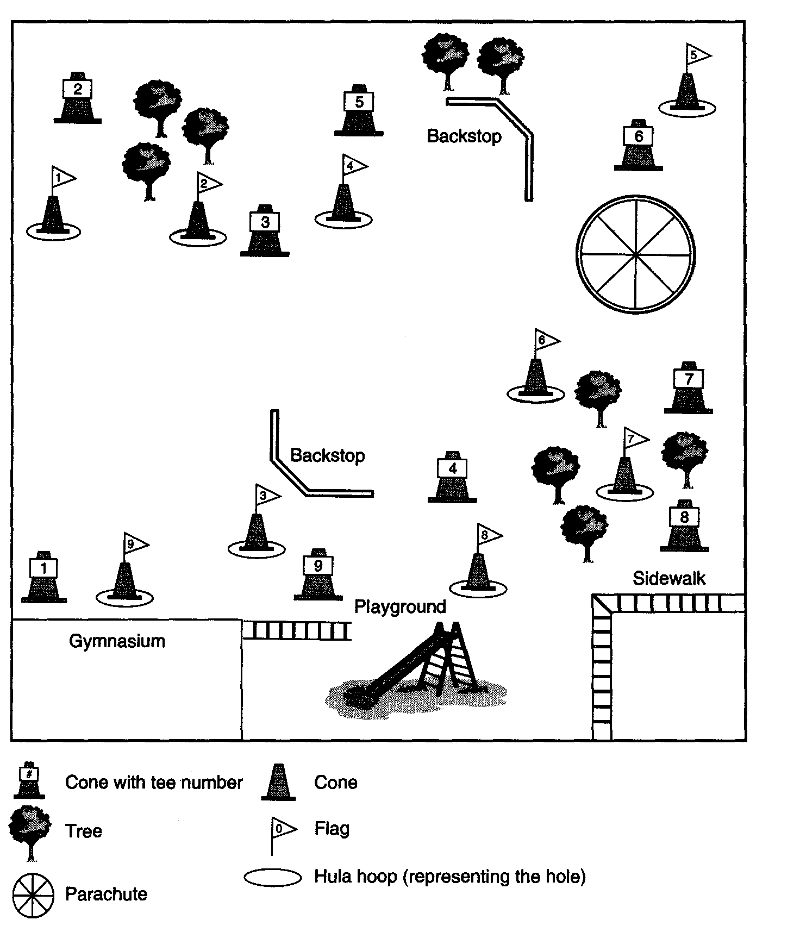

PHYSICAL EDUCATION
LESSON PLAN

NAME: _____________________ TITLE: Pedometer Scavenger Hunt

GRADE: 3-12 DATE: ________________________

SLC: 1 Strand: 3 Physical Fitness

Integration Area (s): Reading and Writing Lesson: 5 of 6
Equipment Needed/materials: Pedometers, log sheets, index cards, and cones/markers.

Lesson/Procedures:
- Objective:
  - To provide students with a fun way to accumulate physical activity.
  - To integrate other academic areas into physical education

- Warm-up: Physical Best, Balancing the Body

- Activity Description:
  - Set up a course similar to an orienteering course.
  - Place an envelope at each marker with an index card for each group (laminating these cards will improve their longevity). Provide a landmark, direction, and distance on each index card, but add a clue to a puzzle that must be solved. This puzzle can be a word, a picture, or a statement, depending on the age level of the students. For example, if eight markers are used, each card could contain two of the following letters PH, YS, IC, AL, AC, TI, VI, and T’I Once all markers have been visited, the students would have eight cards that must be unscrambled to spell PHYSICAL ACTMTY.

- Variations:
  - To add difficulty, scramble the letters (e.g., PY, IC, AL, TV, II, SH, AY, TC). In this variation, the two letters on the card do not necessarily go side by side in the solution PHYSICAL ACTMTY.
  - Cut pictures into eight pieces and paste the pieces on index cards to create a puzzle.
  - Create a puzzle with a physical activity theme to reinforce the concept of lifestyle activity. The puzzle can also integrate other subject areas into physical education. The following ideas for integration could be considered when developing clues and puzzles.

- Classroom Integration:
  - Class spelling words for the week
  - Characteristics of a country, state, or city the class has studied
  - Numbers and math symbols that make a math problem
  - Pictures of coins (or fake coins) that must be added to determine a total
  - Words that describe a specific animal
  - Descriptions of books the class has read
  - Pictures of national monuments or landmarks that have been cut into puzzle pieces

- Group Reflection:
Ask the students how they did today with their responsibility levels and evaluate how they liked the lesson.

PHYSICAL EDUCATION
LESSON PLAN

NAME: _____________________ TITLE: Develop a Personal Fitness Routine

GRADE: 3-12 DATE: ________________________

SLC: 1 Strand: 3 Physical Fitness

Integration Area (s): Reading and Writing Lesson: 6 of 6

Equipment Needed/materials: Pedometers, log sheets, index cards, and cones/markers.

Lesson/Procedures:

- Objective:
  - To monitor the level of fitness activity for each student.
  - To offer students a chance to control the number of steps they accumulate during fitness activities.

- Warm-up: Physical Best, Measuring your heart rate.

- Activity Description:
  - Design a fitness routine that alternates aerobic exercises with strength and flexibility exercises.
  - Ask the students to find a workout partner and give each team the following challenge: Accumulate a total of 1,200 steps. While one person does a strength or flexibility exercise, the other person does aerobic walking, running in place, or any other form of aerobic exercise for 30 to 60 seconds.
  - Have the students switch exercise roles after 30 to 60 seconds and continue until the 1,200 steps are accumulated.
  - Provide the students with various types of PE equipment to assist them with designing their routines.

The goal is to teach students to work together while learning that fitness is personal. In some pairs, one partner may accumulate 700 steps, whereas the other accumulates 500 steps. Teach them to record the steps performed during each interval and to total the number of accumulated steps.

This lesson may have to modified for younger elementary school students.

- Group Reflection:
Ask the students how they did today with their responsibility levels and evaluate how they liked the lesson.

Orienteering via Sport Ed. at the
Elementary School
March, 2003
by, Mary Kennett

CONTENTS

- Introduction

- Unit Goals

- Lessons

- Student Roles

- Point System

- Team Workbook

- Awards

INTRODUCTION

I. Brief Overview:
A. Sport: Orienteering
B. Grade: 4th and 5th (6 classes)
C. Dependent upon class size: 4 to 5 students per team
4 to 5 teams per class
D. 5 core lessons per unit (1 day per week); 40 mins. Per
Lesson. 3 lessons reserved for classroom (in addition to the normal 5 lessons).
E. Student Roles: Captain, Equipment Manager, Warm-up
Leader, Recorder, Publicity Manager
F. Dates of unit: March 17th to April 17th

II. Unit Length:
A. Unit consists of 5 lessons. If time permits I will visit
the classrooms and 3 additional lessons will be included.
B. Regular classes meet one time per week for 40 minutes each.
C. Classes vary in size between 20 to 25 students.

III. Equipment and Facilities:
A. Most lessons will be a combined use of the gymnasium
and outside.
B. April 8, 9, and 10 are day camp experiences for 4th
and 5th grades. Part of the students’ day will be
an orienteering experience at the camp.
C. Equipment: clipboards, writing utensils, team workbook, pedometers, compasses, stopwatches, maps, team disposable cameras, team bag for supplies, and control station supplies.

IV. Unit Goals:
A. Teamwork
B. Increase skills
C. Increase knowledge
D. Attempt to complete given tasks

V. Assessment:
A. Contracts
B. Self and Peer Fair Play Assessment
C. Team completion of Handbook items:
1. Playground Map
2. Map matching exercise
3. Compass parts identification
4. Terminology matching exercise
5. Team pedometer steps
VI. Awards: Given at end of unit
A. Team Awards: Teams will vote by secret ballot :
1. Teamwork Award
2. Overall Performance Award
3. Best Attitude Award
4. Most Enthusiastic Team Award
*Awarded and Displayed by Team Pictures
B. Individual Awards: Captains will help decide:
1. Most Improved Team Member

2. Most Valuable Team Member
3. Team Leader Award
4. Best Attitude Award
*Given to individuals to take home

UNIT GOALS

Knowledge: 1. Students will be able to correctly identify at
least 80% of mapping symbols.

2. Students will be able to correctly identify at
least 80% of orienteering terms.

3. Students will be able to correctly identify at
least 80% of compass parts.

Social: 1. Students will be able to function as a team by respecting the opinions and rights of others.

2. Students will accurately complete the Fair
Play assessment for Self and Peer.

3. The students will demonstrate an
understanding and respect for the environment.

Physical: 1. Students will accurately negotiate a course
using the map and compass skills learned.

2. Students will lead and complete warm-up
exercises prior to each lesson activity.

3. Students will physically complete an
established course while racing other teams.
LESSONS
Week of: March 17th: Lesson #1: -Introduce what Orienteering means.
- Establish Teams and distribute Team Book
-Discuss Contract and everyone sign the form
-Discuss Team roles and complete team info.
-Introduce playground map and discuss the core activity.
-Photo map course; put photo points on map as they are found by the team

Follow-up Lesson #1 with a classroom Lesson #2:
1. Review the photo map course activity and check the team’s map against the teacher’s map.
2. Introduce map symbols and complete the map symbols matching activity in
the team handbook.
3. Introduce the Compasses and the basic parts.

Week of: March 24th: Lesson #3: -Have teams meet together and review the roles.
-The warm-up leader will warm-up the team
using the posted warm-up routine.
-The recorder will get the Team Book and
check attendance for their team.

-The equipment manager will get the team
pedometers and the team compass.
-The publicity coordinator will get the team
camera and take a team picture. They will
be allowed to take 3 to 4 pictures per session.
-The team captain will make sure the team
stays focused and organized.
-Review of compass parts will take place and
how to use the compass.
-We will complete a Real Compass walk
outside (weather permitting; inside if not).
We did the Real Compass Walk in the Gym
with Dr. Tannehill during PEP.
Follow-up Lesson #3 with a classroom Lesson #4:

1. Review the parts of the compass using an overhead projector and the
teacher’s compass.
2. Complete the Compass labeling exercise in the Team Handbook.
3. Complete the terminology matching exercise in the Team Handbook.

Week of: March 31st: Lesson #5: -Begin with the Team meeting format; similar to lesson #3.
-Roles are carried out as in lesson #3.
-Set up small courses with control markers;
outside.
-Start the teams and give them a certain time to find as many markers as the team can.
-Meet back and have teams try a different
course; time permitting.
-Discuss what we will be doing at Camp

Week of: April 7th: Lesson #6: -Camp week; 2 classes attend each of the
3 days.
-There will be approximately 4 to 5 groups
at camp; divide into their orienteering teams.

-All groups will be participating in
cooperative, problem-solving activities.
-One group will be doing an orienteering
course that will start in the open
field and overlap into the edge of the
woods.
-Team Roles will stay the same at Camp.
Camp staff are trained in orienteering
and will assist us.
-The camp is Camp Mary Orton.
-At the conclusion of the day the team will
complete the Team Book worksheet
regarding ‘What Cooperation Means.’
-As with all lessons, the pedometer step sheet will be completed and the team pt. sheet

Week of: April 14th: Lesson #7: -Begin with the usual team meetings and have
students assume and carry out their roles.
-Take any questions on map reading or compasses. Review cooperation, etc. from camp.
-Make sure to encourage the publicity
coordinator to take notes for an article for
the Physical Education Newsletter.
-This lesson will be a Treasure Hunt lesson.
The teams will be given a compass, bearings,
and the playground landmarks will be given
clever Treasure Hunt names, etc.
-Each team will search for their own prize
Follow-up Lesson #7 with a classroom lesson #8:
1. Have teams vote on awards.
2. Confer with captains for individual awards.
3. Give awards
4. Ask students unit debriefing questions.
- Follow-up with publicity coordinators

TEAM ROLES

CAPTAIN

- Be a team leader

- Keep the team focused on the lesson

- Work with teacher to solve problems

- Communicator for the team to the teacher

- Works with the teacher to determine individual awards

EQUIPMENT MANAGER

- Get and give equipment to team members

- Keep track of all equipment

- Make sure equipment is set-up properly

- Collect all equipment at end of lesson and put away properly

WARM-UP LEADER

- Helps captain get team together upon entering the gym

- Leads team in posted warm-ups

- Encourages everyone on team to participate

RECORDER

- Pick-up Team Book

- Organize team to complete data sheets and worksheets for
the day

- Record team points throughout the lesson

- Return Team Book to teacher at end of each lesson

PUBLICITY COORDINATOR

- Responsible for team camera

- Get team picture on 1st day

- Take pictures each lesson

- Help post pictures at end of unit, write captions, and write an article for the newsletter

TEAM BOOK WILL INCLUDE:
- Team profile sheet with attendance format

- Fair play contract

- Fair play peer assessment

- Playground map

- Map matching exercise sheet

- Pedometer steps record sheet

- Terminology matching exercise sheet
- ‘What Does Cooperation Mean to Me?’ sheet

- Team point sheet

AWARDS

Team awards: Voted on by all teams (secret ballot)

-Best Team Cooperation

-Best Team Performance

-Positive Team Attitude

-Most Enthusiastic Team

Individual awards: Decided upon by Team Captain and Teacher

-Most Improved Team Member

-Most Valuable Team Member

-Overall Team Leader

-Best Attitude

-Most Responsible Team Member
ORIENTEERING FOR FITNESS

OBJECTIVES: 1. Students will work on fitness skills.
- Students will practice directionality and compass skills.
- Students will work cooperatively with other group members.

GRADE LEVEL: 4th/5th

MATERIALS NEEDED: 1. 1 writing instrument per group. Groups of no more than 4.
- 5 marker cards with instructions for 5 stations.
- Recording sheet and clipboard per group.
- Pedometers and record sheets.
- A piece of play money for each group at each station.

INTEGRATED AREAS: Math, reading, geography

DESCRIPTION OF ACTIVITY: 1. Instruct students to separate into groups of 4.
2. Have one student be the recorder and come get
writing supplies.
- Equipment manager will get compasses and pedometers for group.
- Groups will get first bearing (compass reading) to first station (each group will start at a different station).
- They go to first station; find card with instructions and bearing reading for next station.
- Instructions will be fitness activity (i.e. each group member must do 15 jumping jacks before moving on).
- Collect one piece of the play money at each station (a check to see if
They went to their station).
- As groups get back they will record their pedometer readings and I will double check their recordings.

DEBRIEF: S.E.L.F. this activity:
- What did you see happening in your groups?
- What did you especially like or dislike about the activity?
- What did you learn by doing this activity?
- How did you feel during the activity?

Using Sport Education at the High School-softball
Softball Season: Brookhaven High School

Day 1: Introduce sport education, softball skills required, discuss and
elect sports council

Day 2: “Spring training camp” skill practice, modified games,
introduction of rules

Day 3: “Spring training camp” skill practice, modified games, review
rules, scrimmage

Day 4: “Spring tryouts” teams will be selected by the members of the
sports council (teacher’s advice will be available if requested)

Day 5: Announce teams, selection of coach, captain, manager,
umpire, scorekeeper

Day 6: Skill and strategy practice in teams, officiating

Day 7: Skill and strategy practice, preseason games, discuss
competition format (multi-level tournament v. round robin)

Day 8-10: Multi-level competition, round 1, one team on duty each day

Day 11: Review round 1; discuss team needs, team practice

Day 12-14 Multi-level competition, round 2, one team on duty each day

Day 15: Brookhaven “Multi-Level World Series” Level winners from
each round will play for the title

Day 16: Celebration to conclusion of season and awards presentation.
Sport Education

Softball Skills

- Using a softball glove
- Throwing
- Fielding fly ball
- Fielding ground ball
- Batting
- Base running
- Rules of game
- Officiating

Tactical problems

1. Scoring
- Getting on base
- Moving the runner
- Advancing to next base

2. Preventing scoring
- Defending space by infield, outfield position
- Defending bases
- Defending space as a team

3. Communication
- Call the ball
- Signaling number of outs
- Informing teammates of play

Election of Sports Council

Your council responsibilities will include
- choosing fair teams
- making final decisions concerning violations of fair play rules
- competition schedules
- planning/preparing for awards and closing festivities

Please circle only (2) names of your classmates that you feel would represent you fairly on the council.

- Tywanna
- Guled
- Dan’neasha
- Robert
- Ning Nong
- Craig
- Leilani
- Brooke
- Precious
- James

Remember this is not a popularity contest, it is a selection of your peers that will make fair and responsible decisions about this sport education season!

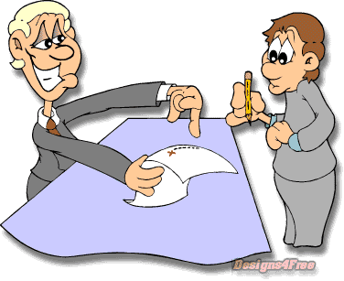
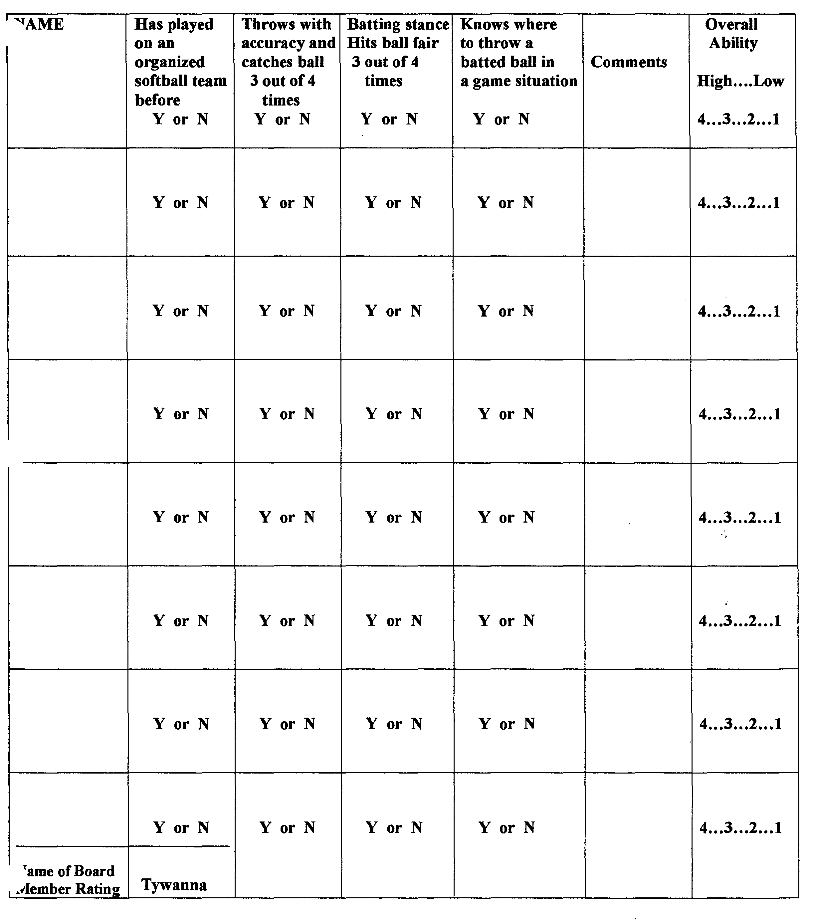
Task: Selection of team roles

Council Member:

You will need to ask each member of your group to get some paper and pencil/pen.

Lead your team in selecting who will serve as captain:

- Read the responsibilities of the captain
- Handout pieces of paper and have a secret ballot
- If there is a clear winner, announce that person as the captain. If there is a tie, repeat the process for a run-off ballot.
- Hand this sheet to the captain

Captain:
Lead your team in selecting who will serve as Coach, Manager, Umpire, and Scorekeeper.
- Read the responsibilities of each position (Coach,Manager,Umpire,Scorekeeper)
- Call for nominations for each position one at a time.
- If more than one person is nominated for a position, give out paper and have a secret ballot.
- If there is a tie, have a run-off secret ballot. (seek advice of council member if tie can’t be broken).
- Give each team member a copy of their role.
- Have each team member sign the Players Fair Play Agreement.

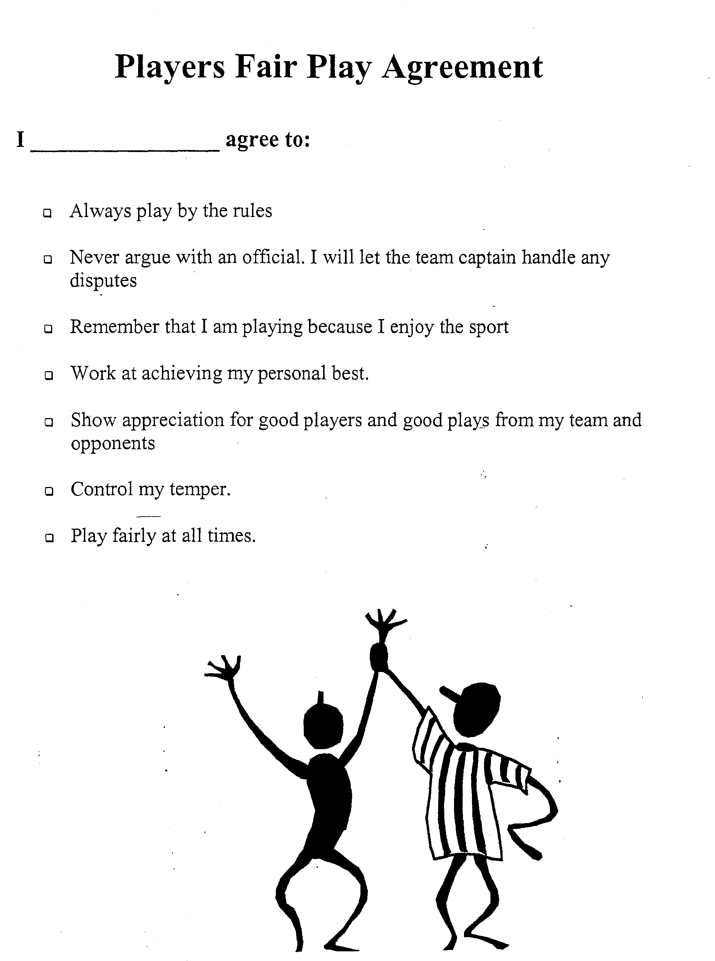

STUDENT ROLES

Captain duties will be as follows:

- Take attendance daily
- Meet with coach to discuss practices and game strategies
- Assist coach with implementation of practices
- Represent the team to umpires during games (only person allowed to talk to umpire about a call)
- Make on-field decisions for team
- Be the example for fair play during games
- Lead the team in congratulations and post competition rituals

Coach duties will be as follows:

- Plan active practices to include skill development and understanding of game situations, seek advice from Ms. Rioux
- Involve all players in practices and games
- Listen to ideas of players, you may not agree but you must give them the opportunity to express themselves
- Discuss ideas with the captain and manager
- Give starting line-up to scorekeeper for recording purposes early before each game
- Make substitutions during all games
- BE FAIR to all players on your team

Manager duties will be as follows:

- Support the coach
- Organize equipment for team practice
- Make sure all players know when to report for games and who they play
- Arrange for substitutes for absent players
- Report concerns to teacher and coach
- Organize the team when it is their duty turn
- Record performance assessments
Scorekeeper duties will be as follows:

- As the scorekeeper, you must be able to focus on the game and keep track of every batter, baserunner, and pitches (balls and strikes)
- Get starting line-up from coach
- Record starting line-up and positions in scorebook
- Give your line-up to the other team to put in their scorebook
- Read out loud the batters (4) in their order at the beginning of each offensive round

Umpire duties will be as follows:

- Fairly implement the rules of the game
- Two umpires needed for each game; a plate umpire to call balls and strikes, another umpire to make calls in the field related to the baserunners
- Keep the game under control, model fair play behavior (no arguing or put downs)

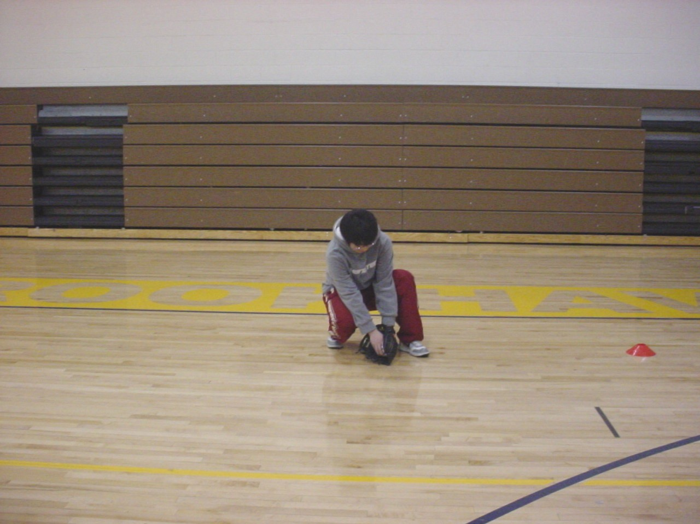
Fielding A Ground Ball
- Ready Position
  - Knees Bent
  - Hands out in front of body
  - Rear end down
- Execution
  - Move feet towards ball
  - Watch ball into glove
  - Cover ball with other hand
- Recovery
  - Raise body up
  - Prepare throw
  - Keep feet moving
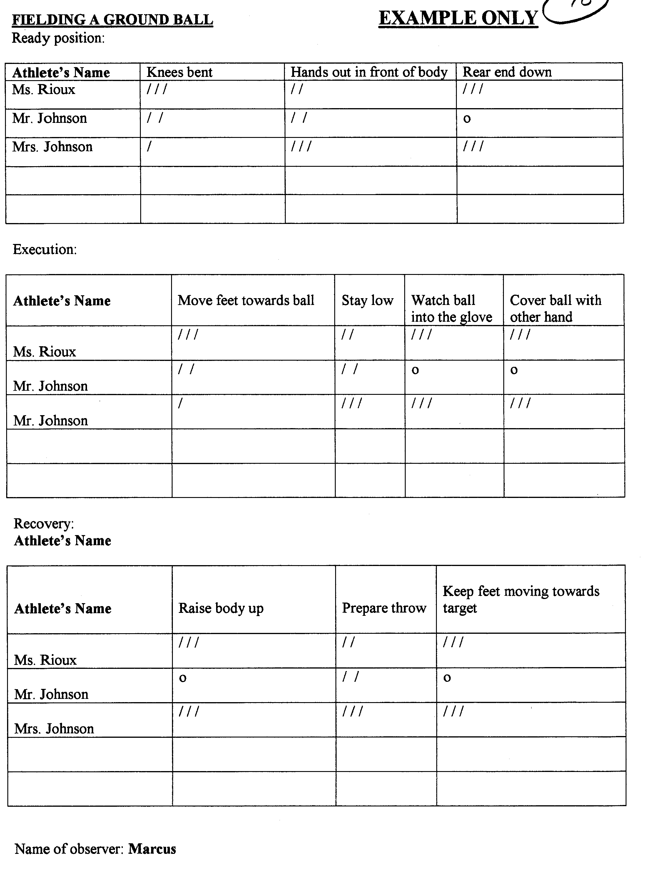
FIELDING A GROUND BALL
Ready position:
Player’s Name | Knees bent | Hands out in front of body | Rear end down

Execution:
Player’s Name | Move feet towards ball | Stay low | Watch ball into the glove | Cover ball with other hand

Recovery:
Player’s Name | Raise body up | Prepare throw | Keep feet moving towards  target
Name of evaluator:

Position Play...Preventing Scoring

Materials needed: 12 bases/half cones, 3 wiffle/softball balls, 3 clipboards and pencils,
2 copies of task analysis sheets per team
Students per team: 6-10
Organization: 3 playing areas/diamonds with home plate area at the center of gymnasium
(1 area per team)

Tactical problem: Defending space by infield position
Objectives: Field grounders from third base and shortstop positions
Make an accurate throw to first base

Game: Zero to Zero, zero runners on base, zero outs.
Goals: Defensive team get runner out at first
Offensive team gets to first base before the throw

Conditions: 4v4, 6v6 maximum. Batter must throw grounder to left side of the infield. Player scores a run by reaching first base safely. Runner may advance at own risk. Bases are cleared after each batter. Inning is over after each batter takes a turn.

- Teacher meet with coaches to explain next practice activity and checklists while players participate in the introductory game.
- Above game will be played for 7 innings or until meeting is finished.

Questions:
- What was the goal of the game for the team on offense?
- Get to first base before the throw.

- What was the goal of the game for the team on defense?
- Get the runner out at first.

- Today we will focus on the defensive team’s performance. As an infielder what
did you do to successfully get the runner out at first?
- Move feet to the ball; watch ball into glove. Throw to first keeping feet moving
toward first base.
- During a defensive inning, when would you throw to first base for a force out?
- With no runners on base and if there are two outs. (For the sure out).
  - Teacher will give all students a demonstration of next activity
  - Coaches meet with their team; explain checklists to players
  - Managers will set up bases for their team’s practice

Practice Situation: Three players in the field… third base, shortstop, first base; three players batting. Extra players (scorekeeper, manager, captain) will be assessing skill performance using a task analysis sheet. Batter throws grounder to left side of infield, and then runs fast to first. Switch third and shortstop positions after fielding three balls from each position. Rotate offense/defense after each defensive position played. Non-fielding player always backs up fielding player. Batting team earns 1 pt. for reaching first base safely; defensive team earns 2 pts. for getting runner out at first base.

Goals: Successfully field three balls in a row from third and from shortstop.
Throw batter out at first base five of six times.

Teaching cues: “You gotta be low and ready to go!”
- Move feet towards the ball (charge it)
- Watch it into your glove
- Throw ball keeping feet moving toward the target

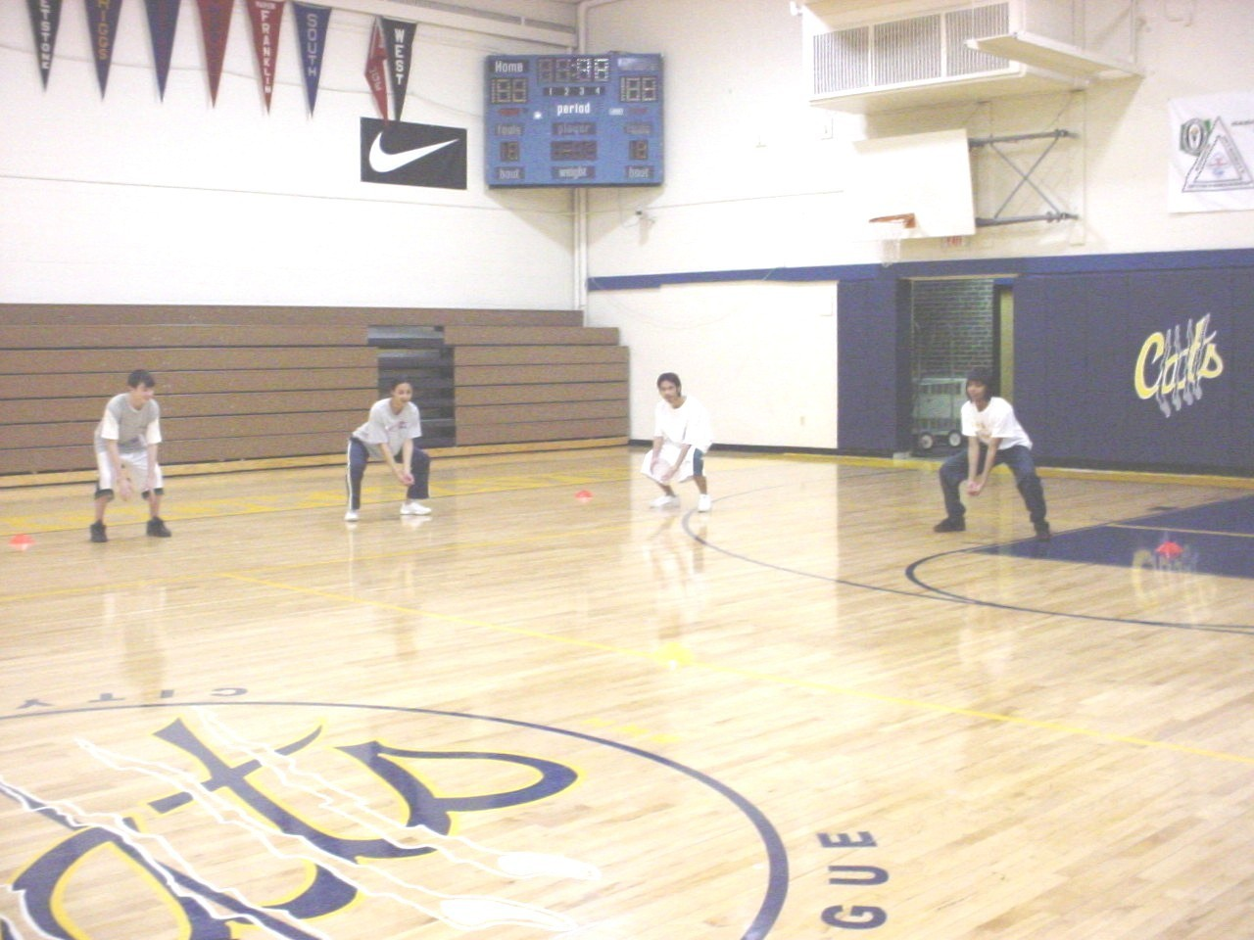

Positioning of Infield Players
INFIELD POSITION PLAY Name of evaluator:

Ready position before the ball is pitched:
Player’s Name | Too close to the base | Too far from the base | Wrong side of the base | Proper position with the base | Comments

Execution:
Player’s Name | Moved toward base to cover when the ball was hit | Backed up player when appropriate | Foot touching corner of base | Comments

Recovery:
Player’s Name | Caught ball and removed foot quickly | Visually located other baserunners | Comments

